# **Installation for Laravel with Composer**

A guide process for Laravel project setup

## **Overview**

In this document you’ll learn how to install Laravel with composer and create Laravel workflow project.

## **Prerequisites:**

1. PHP installed in your computer
2. Install Composer. Check [here](https://getcomposer.org/download/).
3. Code Editor like sublime, VScode, or etc
4. You must have browser

## **Creating Laravel project**

### Installation Via Composer

If your computer already has PHP and Composer installed, you may create a new Laravel project by using Composer directly. After the application has been created, you may start Laravel's local development server using the Artisan CLI's serve command:

composer create-project laravel/laravel example-app

If the process is complete then type the below to go the folder project.

cd example-app

php artisan serve

The “php artisan serve” command will start the Laravel project and it will give you a link to start. Same like this one.

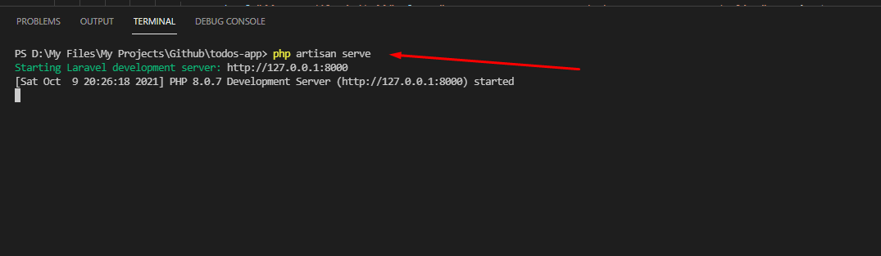

# **Views and Controllers**

## **Overview**

This document will explains the views and controllers in Laravel.

## **Views**

In the path resources/views/welcome.blade.php. It starts the Route for our index page or homepage that served here by artisan <http://127.0.0.1:8000/>. All the files there with .blade.php in the end of the name like welcome.blade.php is page itself that connected to the route in this path routes/web.php

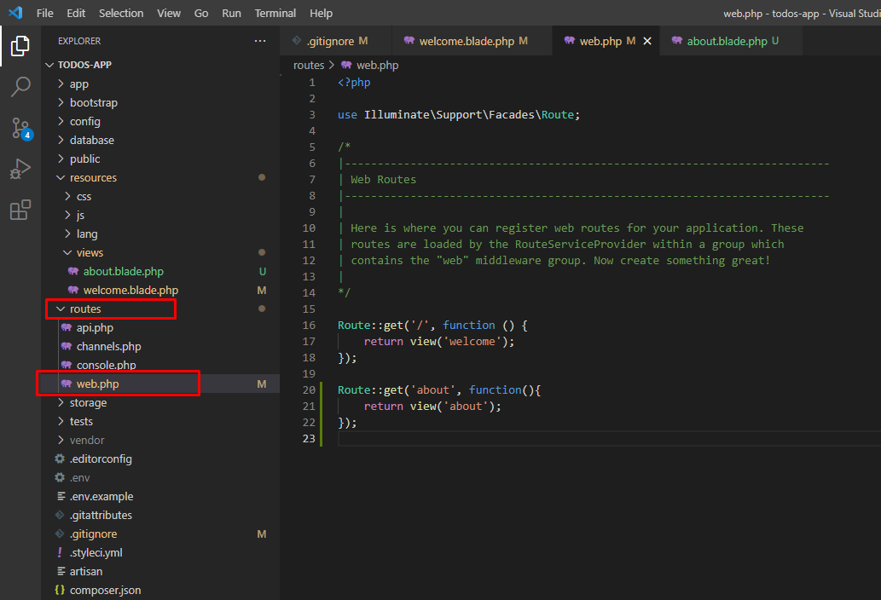

Each route has each view in resources/views having .blade.php in the file name

Route::get('about', function(){

    return view('about');

});

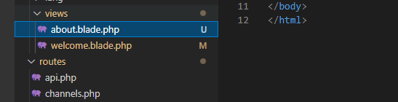

## **Controllers**

This is a php class that tells when user or specific route is visit.

### Create controllers

### Go to the folder app/Http/Controllers/. You can add a php class there but since we using PHP artisan we will make it via terminal

### Type this in your terminal. “ Php artisan make:controllers [ControllerName]. See example below.

### Now instead of returning the route to its view AboutController.php inside in our folder in app/Http/Controllers/AboutController.php. Let the about controller handles the view for our about page.

use App\Http\Controllers\AboutController; //must be in upper

Route::get('about', [AboutController::class, 'index']);